C:\Users\Alex\Desktop\logo3.png **SouthAudioLab**

**dsPIC33 Audio Effects Pedal Project**

**Manual**

**July, 2013**

**V1.01**

The all information and materials what are published by SouthAudioLab have an only for acquaintance and educational purposes. And can be distributed without any restrictions.

The author will appreciate the information about using this materials and source code.

If you have some questions or suggestions, you can contact with us thru feedback.

Best regards and new creative ideas

SouthAudioLab

Contents

Contents 3

Description 3

How to use 4

How to run MATLAB scripts **Ошибка! Закладка не определена.**

References 5

**Goals**

The DSPIC series by Microchip are not powerful but really simplest MCU’s or DSC’s (by Microchip classification) what can be uses for audio processing purposes. This project get ability to create own DSP Pedal, understand how it work, and modify it with own preferences.

Attention:

* **You must have** any Microchip **programmer or/and debugger** (like Pickit 2, Pickit 3, ICD 2, or other, compatible with dsPIC series) to program the device.
* **The project** compiles **in C30 compiler** v3.21 or later. Install it before compilation.
* This Pedal sound quality can be characterized like “may be it can be better”☺, see next chapter.

Pedal Characteristics

# Device characteristics:

**Effect types** 12

**Effects applying** max 4 simultaneous effects

**Patches** -

**Sampling frequency** ~20 kHz

**A/D converter** 12 bit

**D/A converter** 16 bit,

**Signal processing** 32-16 bit

**Frequency response** 20 Hz – 10 kHz

**Display** 1-digit 7-segment LED indicator

**Input** Standard mono phone jack

Rated input level -20 dBm

Input impedance 1 megohm

**Output** Standard stereo phone jack

**Control input** -

**Power requirements**

AC adapter 9 V DC, 300 mA (center minus plug)

**Options** –

Description

There are twelve audio effect algorithms implemented based at dsPIC33FJ1128GP802 DSC IC at custom HW platform. It can apply in chain with four positions:

Zero chain position:

* Hard clipping.
* Soft clipping.
* Compression.

First chain position:

* LP Filter.
* BP Filter.
* HP Filter.

Second chain position:

* Chorus.
* Flange.
* Tremolo.

Third chain position:

* 0.5 second delay.
* Echo.
* Simple reverb

How to run

Open Project at MPLAB X. Assure that C30 compiler installed. Installation description can be found in Appendix A. Press “Make and Program Device” button. If programming completed successfully, the signal what is present at audio input will replies at the output and character “0” will displays at 7-sigment indicator, what is mean that device is ready to use. Please see *dsPIC33AudioEffectsPedalPaper.pdf* at current folder to understand how to use device.

Or use opj.hex file in opj.x folder and program device using any dsPIC compatible programmer

The simplified source code structure can be found in Appendix B. The some photos demonstrated in Appendix C.

Conclusions

Device can be modified in next directions:

* Hardware modifying:

More buttons and LED’s can be added to the device. More substantial improvement is adding the audio ADC or audio CODEC to the project.

* Firmware modifying:

Modify exist or develop own audio effects algorithms.

Appendix A

1. Install C30 compiler, v3.21 or later
2. Check the project properties. The C30 compiler must be active:

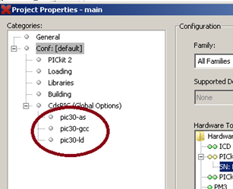

Figure 1 — Project properties.

1. Add C30 libraries to project :

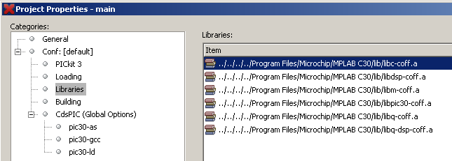

Figure 2 — C30 libraries.

1. Set the next C30 compiler and loader settings:

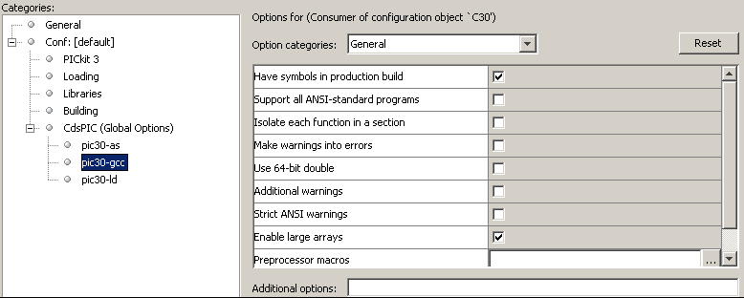

Figure 3 — C30 compiler general settings.

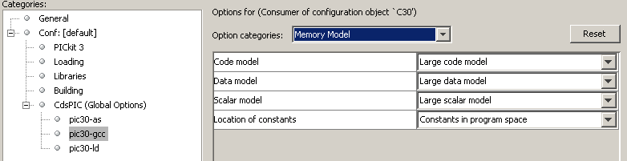

Figure 4 — C30 compiler memory model settings.

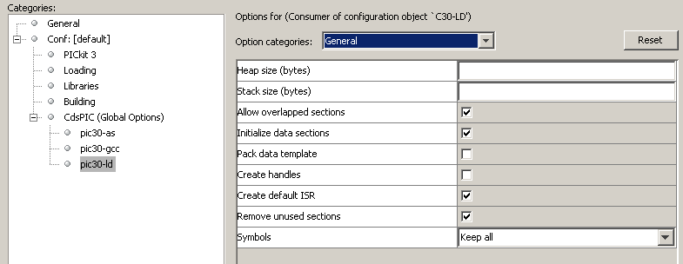

Figure 5 — C30 loader general settings.

1. Create next structure of files in project:

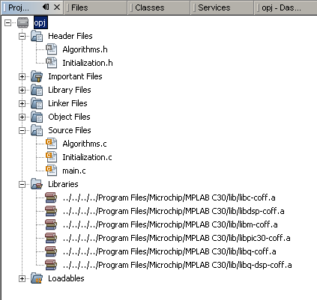

Figure 6 — Structure of project.

Appendix B

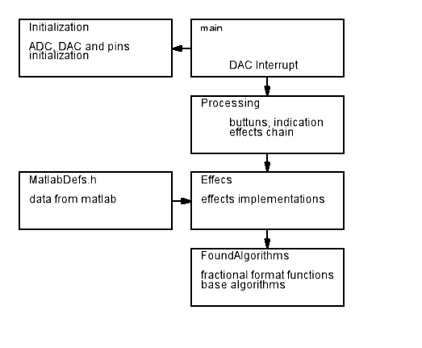

Figure 7 – MPLAB X project structure.

Appendix C

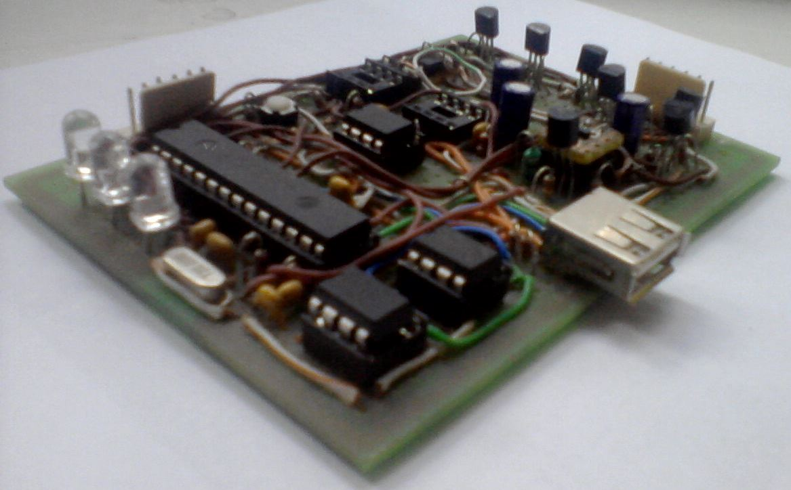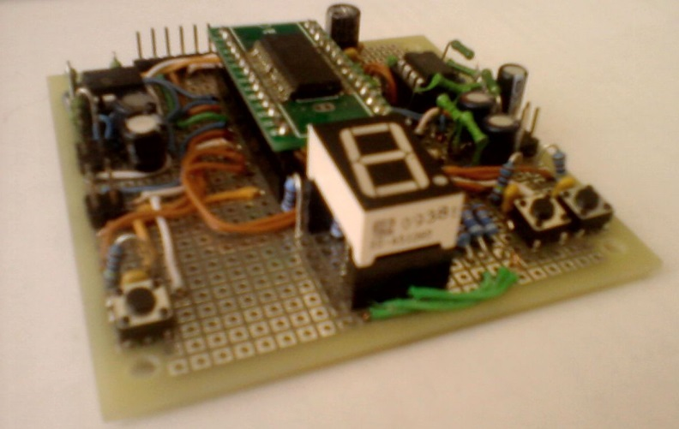

Figure 7 – Hand made PIcKit 2 programmer and device prototype (right).

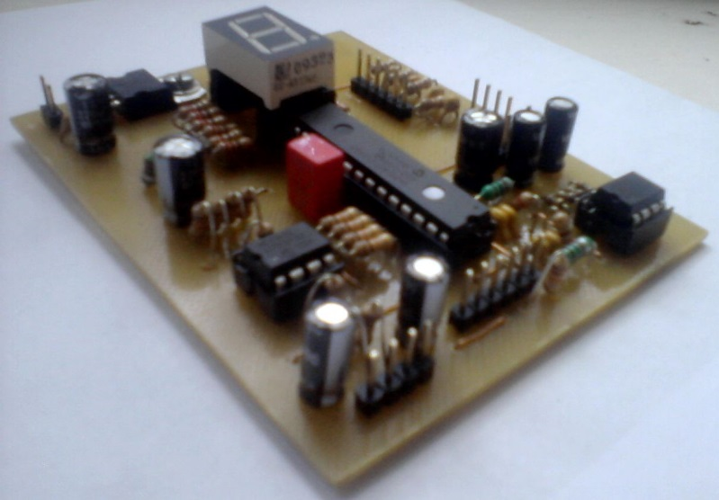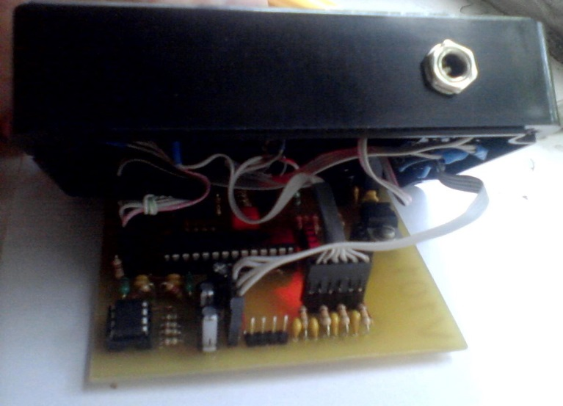

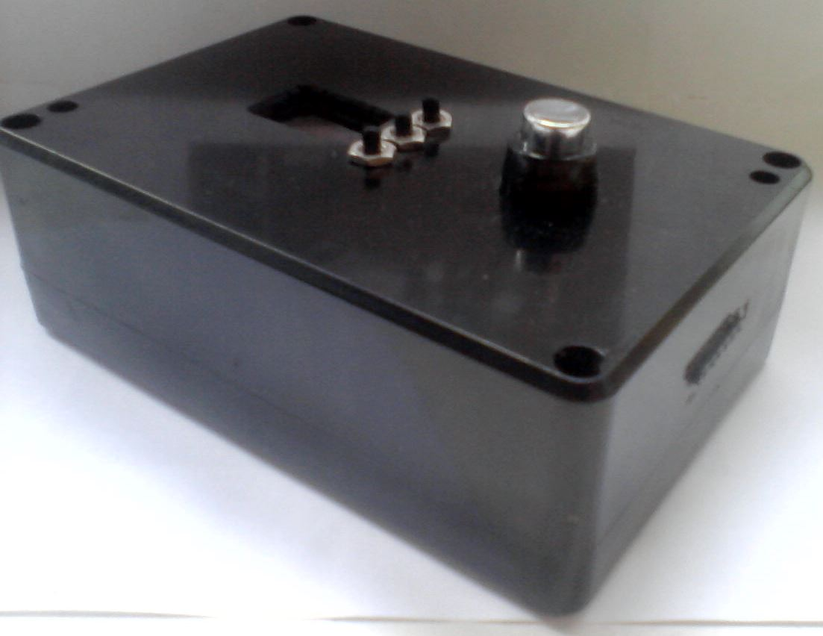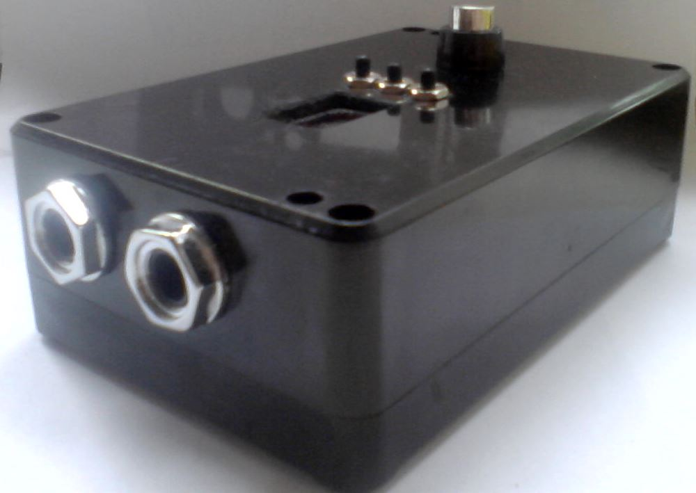

Figure 8 – Device.

References

1*. «DAFX: Digital Audio Effects» Second Edition. Edited by Udo Zolzer.*

2. *www.microchip.com*